# **Dataset_heart Disease: (Positive Correlation)**



**Line Chart:**

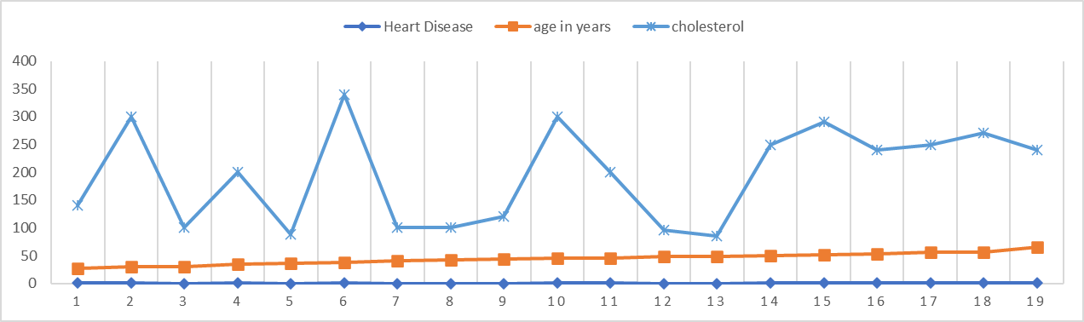

## **Interpretation:**

1. As per the correlation table heart disease and cholesterol are having 0.87 as correlation coefficient which means as the cholesterol level increases, chance of having heart disease also is high
2. Age and heart disease seem correlated weakly i.e. 0.21 but they are positively correlated. It could be due to other external factors such lifestyle, food habits.
3. Age in years and cholesterol levels seems correlated weakly i.e. 0.26 but they are positively correlated
4. Even though chances of heart disease are high when cholesterol levels are high but it’s quite volatile as per the line chart and fluctuations could be due to hereditary and other interrelated genetical conditions etc.

# **Dataset_Covid Vaccinated (Positive, No Correlation)**

**Correlation Table:**



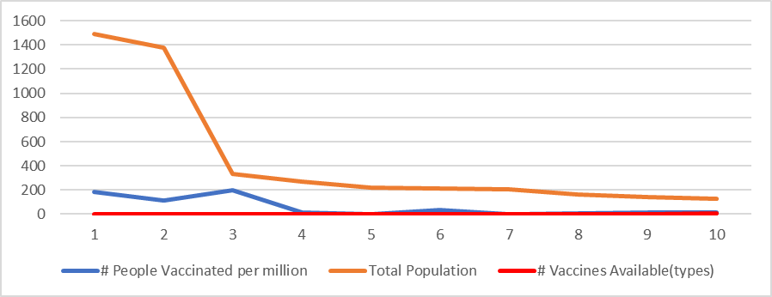

## **Interpretation:**

1. As per the correlation table, people vaccinated and total population of the country having correlation coefficient 0.69 though its not very strong but shows positive correlation. Access to vaccines, # of heath care workers to administrate the vaccine etc. could have influenced negatively
2. People vaccinated and no of vaccines types available surprisingly show very weak correlation, but it is positively correlated. Though there are many vaccines types are approved but if production rate and workers to administrate the vaccines are less then not more people would have vaccinated
3. Total population and number of vaccines types show almost no correlation. If the countries are not developed countries, then access to research to create vaccine or to procure vaccines from other countries is challenging

# **Dataset_age (Positive Correlation)**

**Correlation Table:**



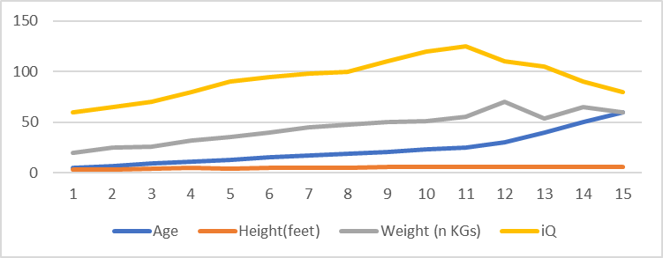

## **Interpretation:**

1. As the age increases, height increases, and weight increases, so there appears to be a positive relationship
2. There is a positive relationship between height and weight; that is, when height increases, weight also tends to increase.
3. There is a positive correlation between age and iQ but seems its in downward trend after 23 years of age.

# **Dataset_Stock Prices (Negative Correlation)**

**Correlation Table:**

Note: A price index is a normalized average (typically a weighted average) of price relatives for a given class of goods or services in each region, during a given interval of time**.**



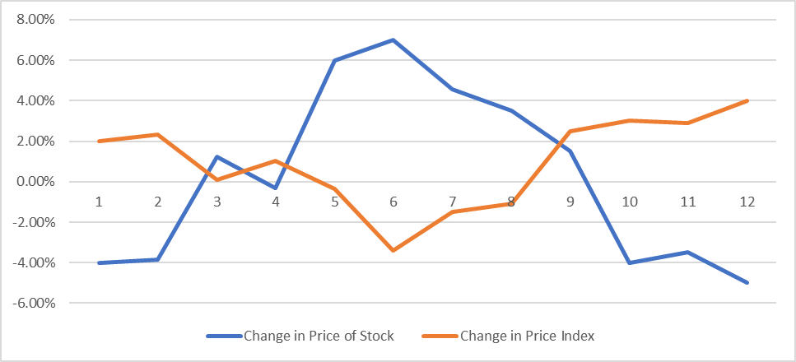

## **Interpretation:**

1. Price Index and Price of stock show negative correlation which means as market raises, the stock price falls and when market falls, the stock price raises